**FLUTTER CLASS TASK**

**🚀 Space Explorer - Discover the Universe**

**Space Explorer** is a mobile application designed to help users explore and navigate the vast world of space through real-time NASA data.

**PROJECT SETUP**

**STEP 1: Page Creation**

* **Home Page** (Explore the Universe)
* **Astronomy Picture of the Day (APOD) Page**
* **Mars Rover Photos Page**
* **NASA News Page**

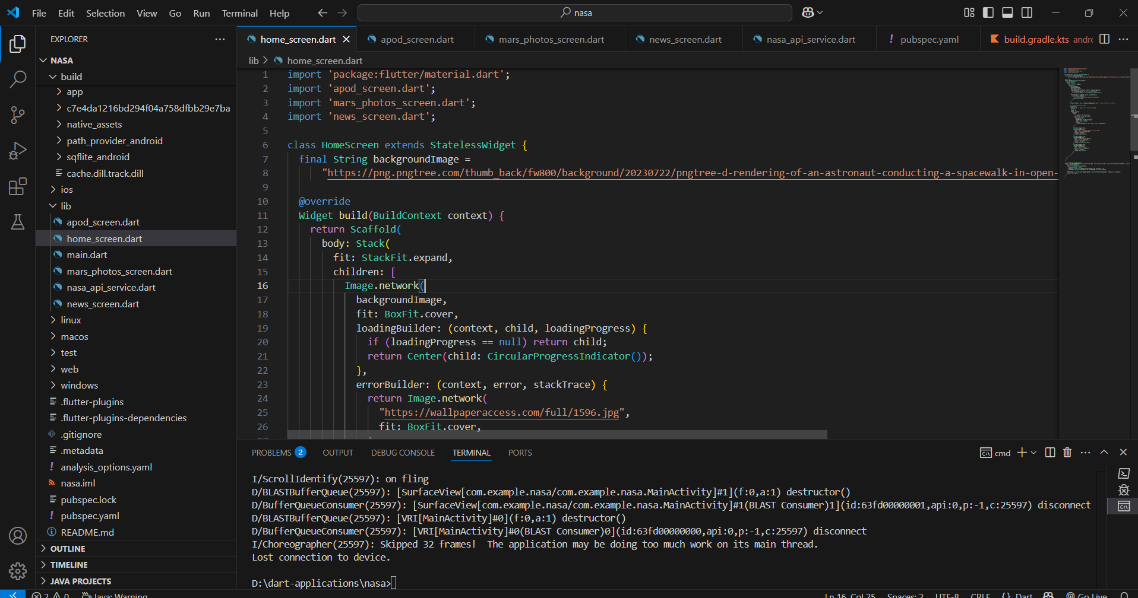

**STEP 2: API Usage**

**Astronomy Picture of the Day (APOD)**

* **API Used:** [**NASA APOD API**](https://api.nasa.gov/planetary/apod)

#### **Mars Rover Photos**

* **API Used:** [NASA Mars Rover Photos API](https://api.nasa.gov/mars-photos/api/v1/rovers/curiosity/photos)

**NASA News**

* **API Used:** [**NASA Image and Video Library API**](https://images-api.nasa.gov/)

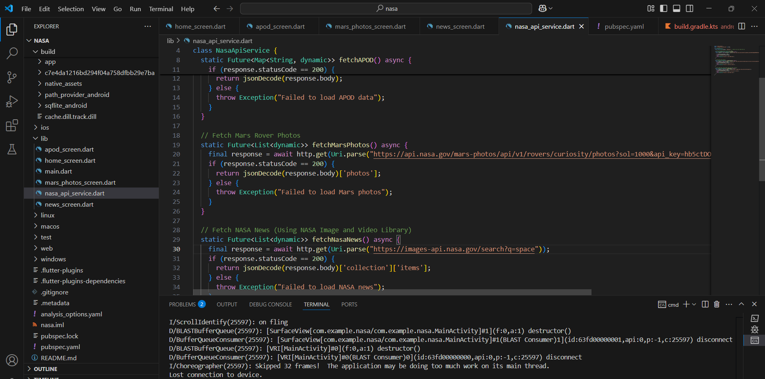

**STEP 3: Dependencies**

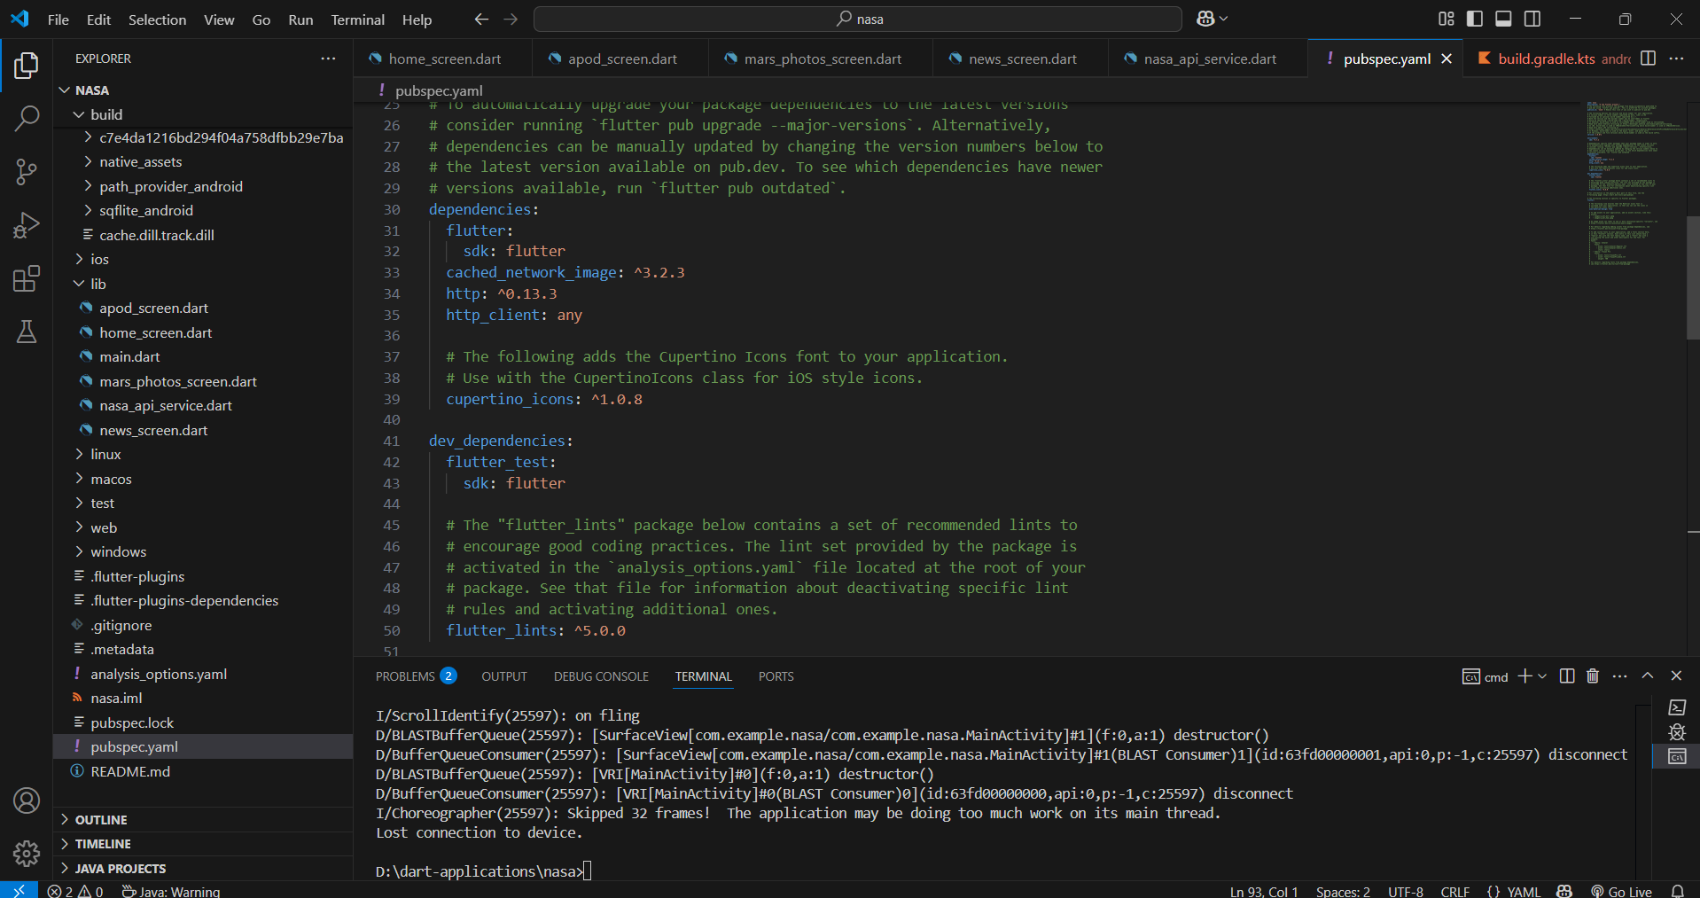

**OUTPUT:**

**NAVIGATION FLOW**

* 1. **HOME PAGE (Explore the Universe)**
* A space-themed background with an astronaut and satellite.
* A welcoming title: "Explore the Universe" with space-related emojis.
* Three buttons leading to different sections:
  + 🧑‍🚀 Astronomy Picture of the Day (Fetches NASA’s daily astronomy image and description).
  + 🚜 Mars Rover Photos (Displays images taken by NASA’s Mars rovers).
  + 📰 NASA News (Provides the latest space-related news).

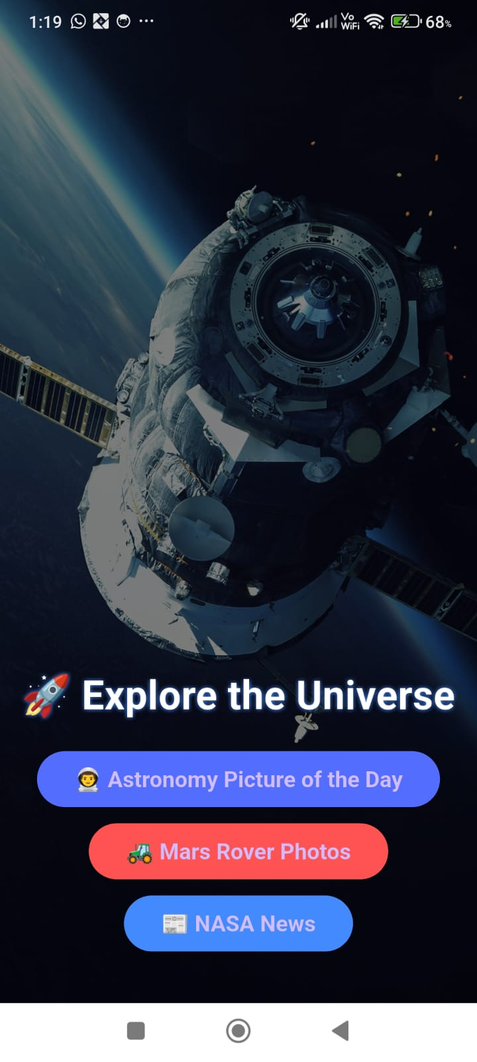

* 1. **Astronomy Picture of the Day Page**

(Fetches NASA’s daily astronomy image and description).

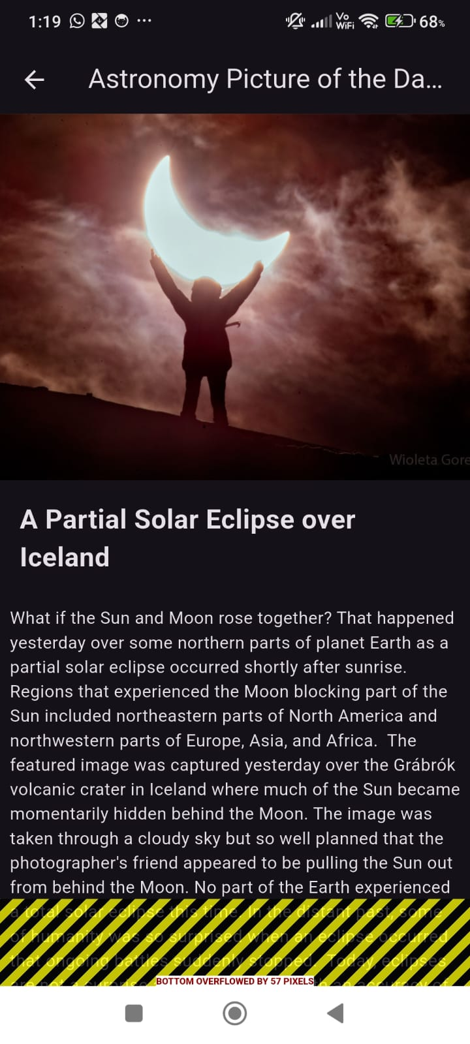

* 1. **🚜 Mars Rover Photos** (Displays images taken by NASA’s Mars rovers).

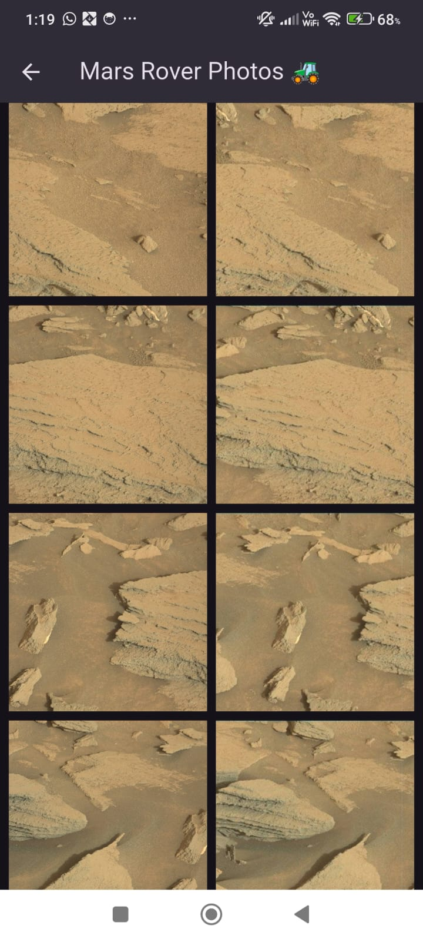

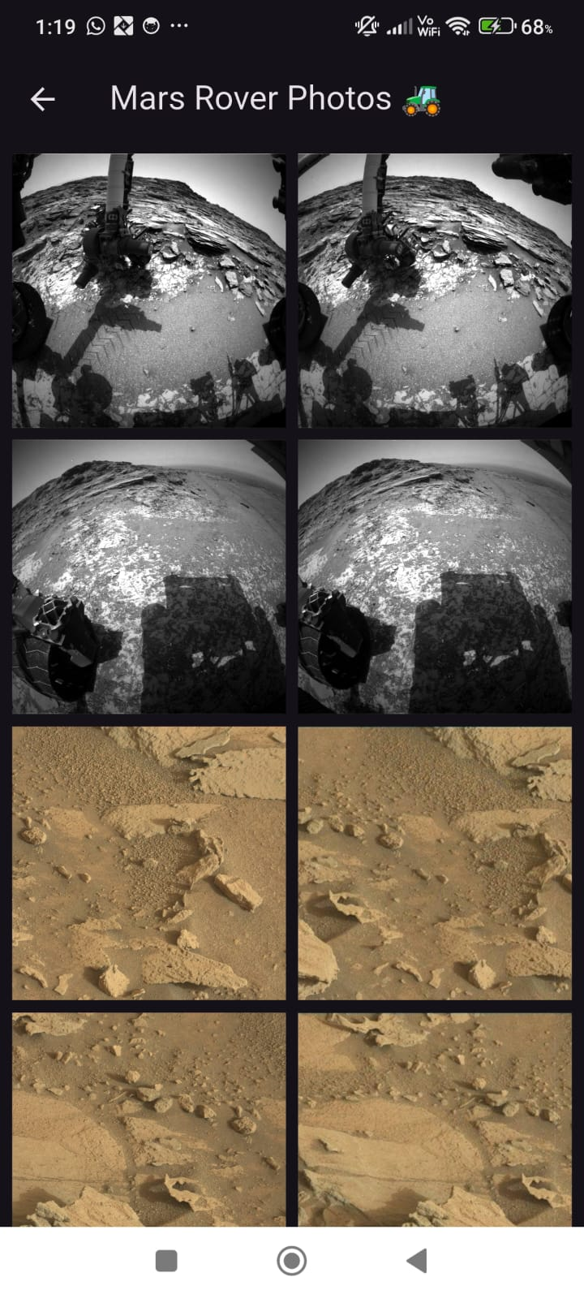

* 1. **📰NASA News(Provides the latest space-related news).**

